Random Steps and Choices

Look at this code:
import random
even_step = random.randrange(2, 13, 2)
colour = random.choice(["red", "blue", "gold"])
print("Move:", even_step)

What do you think this code will display?
Click or tap here to enter text.

Run the code. Compare the result with your prediction:
Click or tap here to enter text.

Let’s investigate! Answer the questions below:
- Why can random.randrange(2, 13, 2) produce 12 but not 13?
Click or tap here to enter text.

- Why can random.choice() return only an item already present in its collection?
Click or tap here to enter text.

- Why does using the same seed produce the same two results when the starter program is run again?
Click or tap here to enter text.

- With seed 4, what two output lines appear?
Click or tap here to enter text.

Random Steps and Choices

Look at this code:
import random
even_step = random.randrange(2, 13, 2)
colour = random.choice(["red", "blue", "gold"])
print("Move:", even_step)

Use the code above to help you. After completing each challenge below, run your program to test that it works correctly. Save each completed challenge program in a new file.

Programming Challenges

Challenge 1
Use randrange() to generate one of these whole numbers: 5, 10, 15, 20, 25 or 30. Store the result in [move] and display "Move:" followed by [move]. Run the program several times and check that no other number appears.
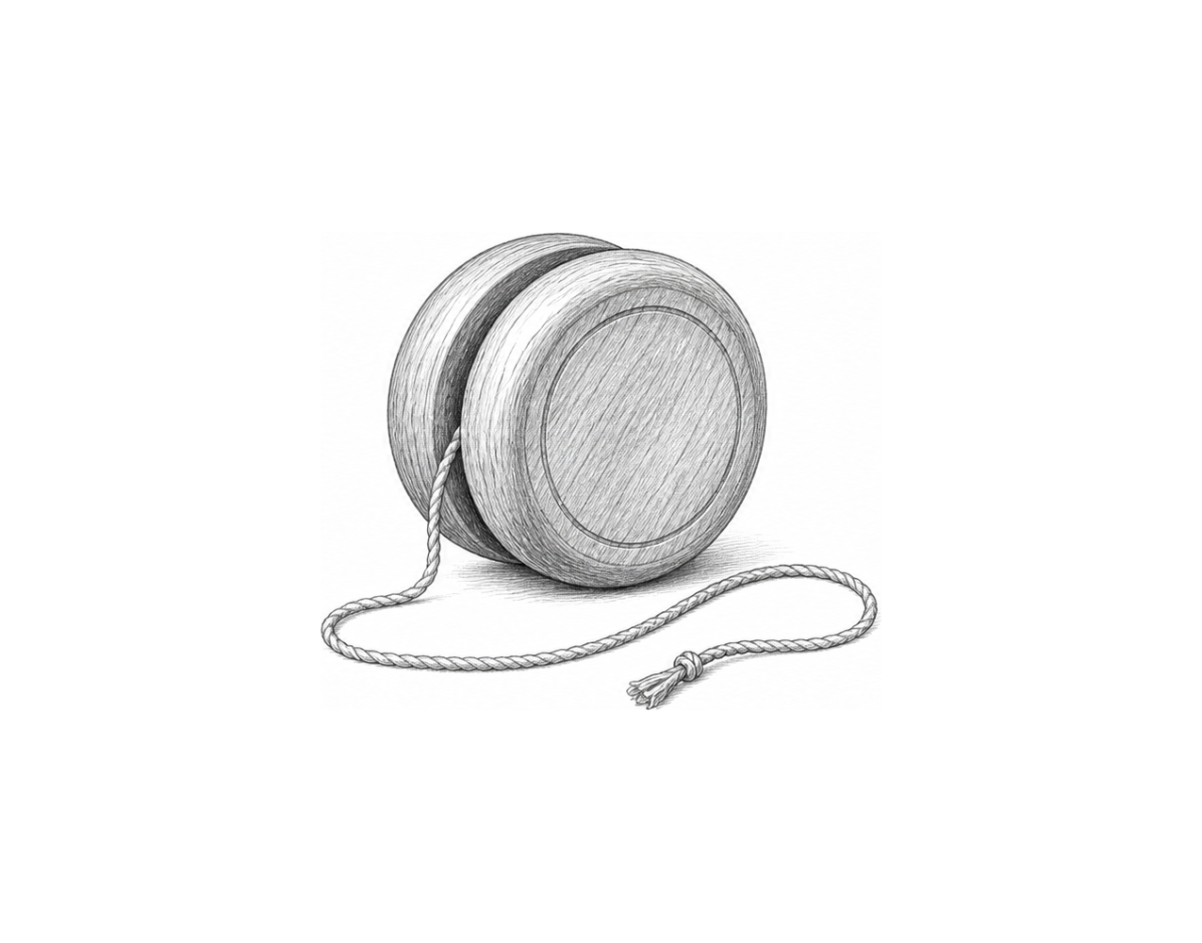

Challenge 2
Add "green" to [colours]. Use random.choice() twice and store the results separately in [first_colour] and [second_colour]. Display each result on a labelled line. For example, if "red" and "green" are selected, display "First colour: red" and "Second colour: green".

Challenge 3
Store three activity strings, such as "jumps", "push-ups" and "squats", in [activities]. Generate a random even whole number from 2 through 12 and store it in [count]. Select one random item from [activities] and store it in [activity]. Display "Training prompt:" followed by [count] and [activity], such as "Training prompt: 8 jumps" or "Training prompt: 4 push-ups".

Random Steps and Choices

Fix the code!

This code has errors! Look closely at the code to find the problems:

import random
random.seed(4)
even_step = random.randrange(2, 12, 2)
colours = ["red", "blue", "gold"]
colour = random.choice
print("Move:", even_step)
print("Colour:", colour)

Rewrite the whole program in the box below with fixes to the errors.
Click or tap here to enter text.

After you are confident that you fixed all the errors, copy the code from the box and run it.

Did it work correctly on your first try? Did you find all the errors?
Click or tap here to enter text.

